Delhi Public School

Faridabad

Computer Science (C++)

Project

Pharmacy Management

Shashank Sengar

Acknowledgements

I am extremely grateful to my teacher Mr. Ankush Mehta for his able guidance and useful suggestions, which helped me in completing the project work. My gratitude also extends to The Principal, Mr. Anil Kumar.

Secondly I would also like to thank my beloved parents and friends for their help and wishes for the successful completion of this project.

Certificate

This is to certify that Shashank Sengar, student of class XII-C, of Delhi Public School, Faridabad has completed the C++ project during the academic year 2018-19 towards partial fulfilment of credit for the Computer Science Project evaluation.

The file is the result of his efforts & endeavours. The file is found worthy of acceptance as final project file for the subject “Computer Science” of class XII. He has prepared the file under my guidance.

_ _ _ _ _ _ _ _ _ _ _ _ _

Teacher’s Signature

Pharmacy Management

Description and Source Code

A basic program for management of medicines and their sale in a Pharmacy, the program allows you to add new medicines to a file maintaining list of medicines, sell medicines, get overview of the stock and search for particular medicines.

Classes

medicine class

* Data Members:
  + private int K : Serial Number of Medicine
  + private char name[20] : Name of Medicine
  + private int quantity : Stock Quantity of Medicine
  + private float u_price : Price of One Unit
* Member Functions:
  + public void getDetails() : To input details of medicine from user.
  + public void showDetails() : To read and show all medicines from file.
  + public float rPrice() : Returns price of medicine.
  + public int rQuantity(): Returns quantity of medicine.
  + public int rK(): Returns serial number of medicine.
  + public void changeK(int newK) : Changes value of serial number of medicine.
  + public void decQuantity(int dQ) : Decreases quantity of medicine in stock.
  + public char* rName(): Returns pointer to string storing name of medicine.

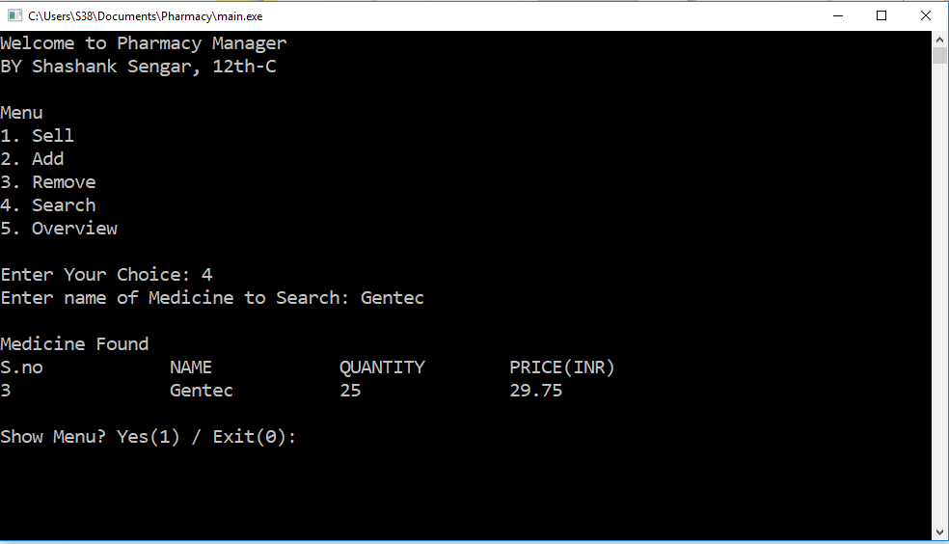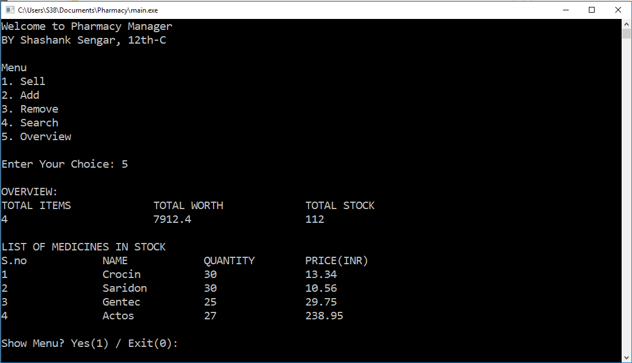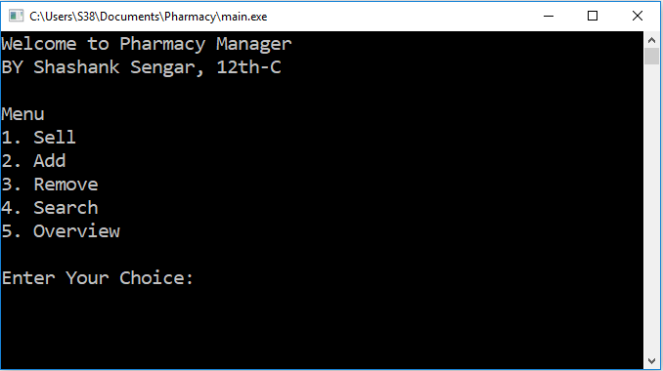Output Screens

